Internal Assessment Test 1- Oct. 2024

SCHEME & SOLUTION
Sub: | Cryptography and Network Security | Sub Code: | 21IS71 | Branch: |  | ISE
Answer any FIVE FULL questions |  |  |  |  | MARKS | CO | RBT
1a | Primitive Data Types Primitive types are the most basic types in JavaScript. They represent single values and are immutable (cannot be changed after creation). These types include:  Non-primitive data types, also called reference types, are more complex than primitive types. They store references to the data rather than the actual data. Modifying an object or array will affect all references to it. |  |  |  | 3+2=5M | CO1 | L2
1b | A closure is the combination of a function bundled together (enclosed) with references to its surrounding state (the lexical environment). In other words, a closure gives a function access to its outer scope. In JavaScript, closures are created every time a function is created, at function creation time. |  |  |  | 3+2=5M | CO1 | L2
2a | In JavaScript, == (loose equality) performs type coercion before comparison, while === (strict equality) does not, requiring both value and type to be identical for a true result. |  |  |  | 3+2=5M | CO1 | L2
2b | Function Declaration  A function declaration defines a function with a specified name. It is hoisted to the top of its scope, meaning it can be called before it is defined in the code.  function add(a, b) {  return a + b;  }  Function Expression  A function expression defines a function as part of an expression. It can be anonymous (without a name) or named. Function expressions are not hoisted and must be defined before they are called.  const multiply = function(a, b) {  return a * b;  };  const subtract = (a, b) => {  return a - b;  };  Arrow Function  An arrow function provides a concise syntax for writing function expressions. It does not have its own this context, arguments object, or super keyword, and cannot be used as a constructor. Arrow functions are often used for short, simple functions.  const divide = (a, b) => a / b; |  |  |  | 3+2=5M | CO1 | L2
3a | The this keyword in JavaScript is a reference variable that is automatically assigned a value when a function is called. It refers to the object that is executing the current piece of JavaScript code. The value of this is not determined by how or where a function is declared, but by how it is called – the call-site.  In JavaScript, the this keyword refers to the object that is currently executing the code. Its value is determined by how a function is called, not where it is defined. Here's how this behaves in different contexts:  1. Global Context  When this is used outside of any function, it refers to the global object. In browsers, this is usually the window object.  JavaScript  console.log(this === window); // true (in browsers)  2. Function Context  - Simple Function Call: In a regular function call, this refers to the global object (or undefined in strict mode).  JavaScript  function showThis() {  console.log(this === window);  }  showThis(); // true  - Method Call: When a function is called as a method of an object, this refers to the object that owns the method.  JavaScript  const obj = {  name: 'John',  greet: function() {  console.log('Hello, ' + this.name);  }  };  obj.greet(); // Hello, John  - Constructor Call: When a function is used as a constructor with the new keyword, this refers to the newly created instance.  JavaScript  function Person(name) {  this.name = name;  }  const person = new Person('Alice');  console.log(person.name); // Alice |  |  |  | 2+3M | CO1 | L2
3b | Loops allow you to execute a block of code repeatedly.  Types of Loops:  1. for Loop:  o Used when the number of iterations is known.  for (let i = 0; i < 5; i++) {  console.log(i); // Output: 0, 1, 2, 3, 4  }  2. while Loop:  o Executes as long as the condition is true.  let i = 0;  while (i < 5) {  console.log(i); // Output: 0, 1, 2, 3, 4  i++;  } |  |  |  | 2+3=5M | CO1 | L2
4a | Selecting by Tag Name • The getElementsByTagName() method selects all elements with a specific tag name.  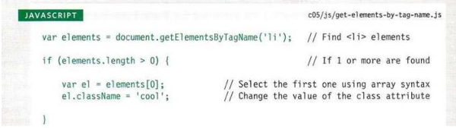  Selecting Using Query Selectors • querySelector(): Selects the first element that matches a given CSS selector. • querySelectorAll(): Selects all elements that match a given CSS selector.  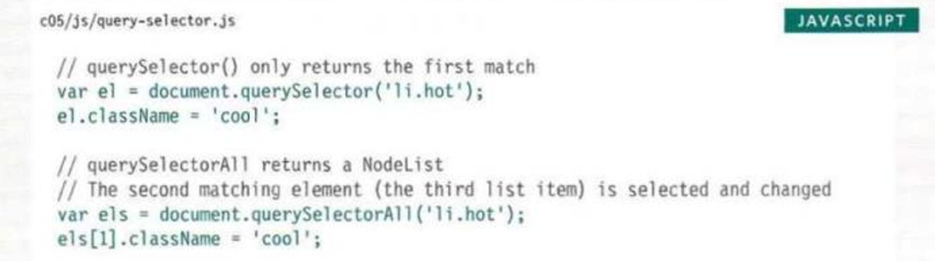 |  |  |  | 4+1=5M | CO2 | L2
4b | The capturing phase  The first phase is the capturing phase, which occurs when an element nested in various elements gets clicked. Right before the click reaches its final destination, the click event of each of its parent elements must be triggered. This phase trickles down from the top of the DOM tree to the target element.  The bubbling phase  The bubbling phase, which is the last phase, is the reverse of the capturing phase. In this phase, the event bubbles up the target element through its parent element, the ancestor, to the global window object. By default, all events you add with addEventListener are in the bubble phase.  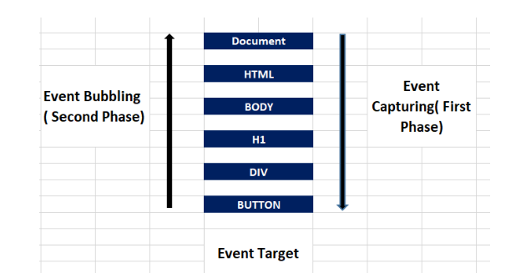 |  |  |  | 4+1=5M | CO2 | L2
5a | For more customized validation logic, JavaScript event listeners such as addEventListener can be used to trigger validation functions on form submission or input changes. This approach allows developers to define complex validation rules and provide instant feedback to users. |  |  |  | 4+1=5M | CO2 | L2
5b | . Required Field Validation  This validation ensures that certain fields must be filled out before the form can be submitted.  if (usernameInput.value.trim() === '') {  usernameFeedback.textContent = 'Username is required.';  2. Email Format Validation  This validation checks if the entered email address is in a valid format.  const emailPattern = /^[^\s@]+@[^\s@]+\.[^\s@]+$/;  if (!emailPattern.test(emailInput.value)) {  emailFeedback.textContent = 'Please enter a valid email address.';  3. Password Strength Validation  This validation checks if the password meets certain criteria, such as length, inclusion of numbers, and special characters.  passwordInput.addEventListener('input', function() {  const password = passwordInput.value;  const isValid = password.length >= 8 && /[A-Z]/.test(password) && /[0-]/.test(password) && /[!@#$%^&*]/.test(password);  4. Real-time Validation Using Event Listeners  Real-time validation provides immediate feedback to users as they fill out the form. This can be applied to various fields, such as required fields, email, and password.  const form = document.getElementById('myForm');  // Real-time validation for username  document.getElementById('username').addEventListener('input', function() {  const usernameFeedback = document.getElementById('usernameFeedback');  usernameFeedback.textContent = this.value.trim() === '' ? 'Username is required.' : '';  });  // Real-time validation for email  document.getElementById('email').addEventListener('input', function() {  const emailFeedback = document.getElementById('emailFeedback');  const emailPattern = /^[^\s@]+@[^\s@]+\.[^\s@]+$/;  emailFeedback.textContent = !emailPattern.test(this.value) ? 'Please enter a valid email address.' : '';  });  // Real-time validation for password |  |  |  | 1+1+1+2=5M | CO2 | L2
6a | Event delegation is a technique in JavaScript where a single event listener is attached to a parent element instead of multiple listeners on individual child elements.  Example of Event Delegation  Let's implement event delegation using the above HTML structure. We will add a click event listener to the <ul> element that will handle clicks on its <li> children. |  |  |  | 3+2=5M | CO2 | L3
6b | The Document Object Model (DOM) represents an HTML or XML document as a tree-like structure, organizing its elements into a hierarchy.  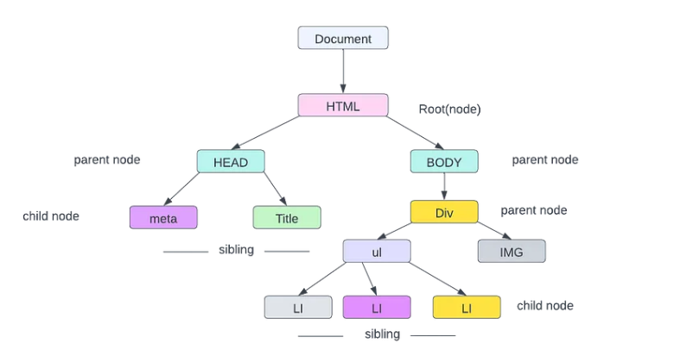 |  |  |  | 3+2=5M | CO2 | L3

